

Practices for Secure Software Report

Document Revision History
Version | Date | Author | Comments
1.0 | October 15, 2026 | Antonio Porter | Initial submission of Practices for Secure Software Report

Client
Artemis Financial


Instructions
Submit this completed practices for secure software report. Replace the bracketed text with the relevant information. You must document your process for writing secure communications and refactoring code that complies with software security testing protocols.
- Respond to the steps outlined below and include your findings.
- Respond using your own words. You may also choose to include images or supporting materials. If you include them, make certain to insert them in all the relevant locations in the document.
- Refer to the Project Two Guidelines and Rubric for more detailed instructions about each section of the template.

Developer
Antonio Porter

1. Algorithm Cipher
For Artemis Financial's file verification requirement, I selected SHA-256 (Secure Hash Algorithm 256-bit) as the cryptographic hash function. SHA-256 is a member of the SHA-2 family, published by the National Security Agency and standardized by NIST. It produces a fixed 256-bit (32-byte) hash value regardless of input size, providing approximately 2^128 collision resistance.
Hash functions and bit levels: SHA-256 outputs a 64-character hexadecimal string. This 256-bit space is large enough that brute-force collision attacks are computationally infeasible. By comparison, MD5 (128-bit) and SHA-1 (160-bit) have both been broken — practical collision attacks were demonstrated in 2004 (MD5) and 2017 (SHA-1, the SHAttered attack). SHA-256 remains secure and is the industry standard for data integrity verification.
Symmetric vs. asymmetric keys and random numbers: SHA-256 is a one-way cryptographic hash function and does not use keys — it is deterministic, meaning the same input always produces the same output. This makes it ideal for checksum verification. Symmetric encryption (e.g., AES) uses a single shared key for encryption and decryption. Asymmetric encryption (e.g., RSA) uses a public-private key pair and is used for key exchange and digital signatures. Random numbers (salts) are added to hash functions when hashing passwords to prevent rainbow-table attacks; for file checksum verification, salts are not required because the goal is integrity, not secrecy.
History and current state: The SHA family originated in 1993 with SHA-0, followed by SHA-1 in 1995. SHA-2 was published in 2001. SHA-1 was deprecated after 2017 when Google and CWI Amsterdam demonstrated the SHAttered collision attack. SHA-3 was finalized in 2015 as an alternative design. Today, SHA-256 is required by NIST for federal applications and is used in TLS certificates, blockchain, code signing, and file integrity verification.

2. Certificate Generation
I generated a self-signed certificate using the Java keytool utility, which ships with the JDK. The command used was:
text
keytool -genkeypair -alias tomcat -keyalg RSA -keysize 2048 -validity 3650 -keystore keystore.p12 -storetype PKCS12
Key details:
- Alias: tomcat
- Algorithm: RSA with a 2048-bit key
- Validity: 3650 days (10 years)
- Keystore format: PKCS12
- Common Name (CN): localhost (must match the domain used in the browser)
- Issued to / Issued by: Antonio Porter (self-signed)
I exported the certificate as a CER file using:
text
keytool -exportcert -alias tomcat -keystore keystore.p12 -file cert.cer
Screenshot of CER file:
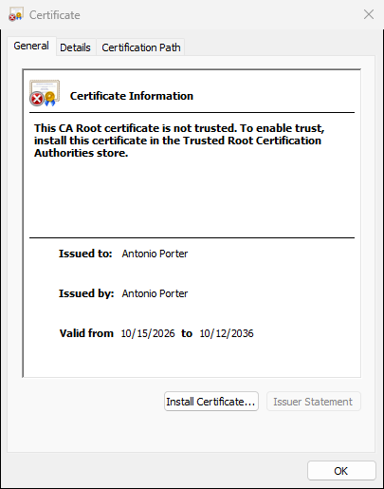

3. Deploy Cipher
I refactored SslServerApplication.java to add a REST controller with a /hash endpoint. The controller calls a calculateSHA256 method that uses Java's built-in MessageDigest class:
java
MessageDigest digest = MessageDigest.getInstance("SHA-256");
byte[] hash = digest.digest(data.getBytes(StandardCharsets.UTF_8));
The byte array is then converted to a 64-character hexadecimal string using Integer.toHexString.
Data string used: Antonio Porter - CS305 - Unique String 2026
SHA-256 checksum produced: 77888a2b973996cbd56ca79a58ee17f7fc3fae53423a1149ab6253347f8a4075
Screenshot of checksum verification:
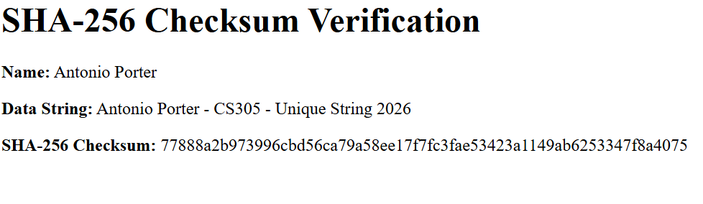

4. Secure Communications
I modified src/main/resources/application.properties to convert the application from HTTP to HTTPS:
properties
server.port=8443
server.ssl.key-alias=tomcat
server.ssl.key-store-password=changeit
server.ssl.key-store=keystore.p12
server.ssl.key-store-type=PKCS12
server.ssl.enabled=true
After recompiling and running the application, I navigated to https://localhost:8443/hash. The browser displayed a warning that the certificate is self-signed and untrusted, which is expected for a development certificate. After accepting the risk, the page loaded over HTTPS, confirming that secure communication is working.
Screenshot of secure webpage:
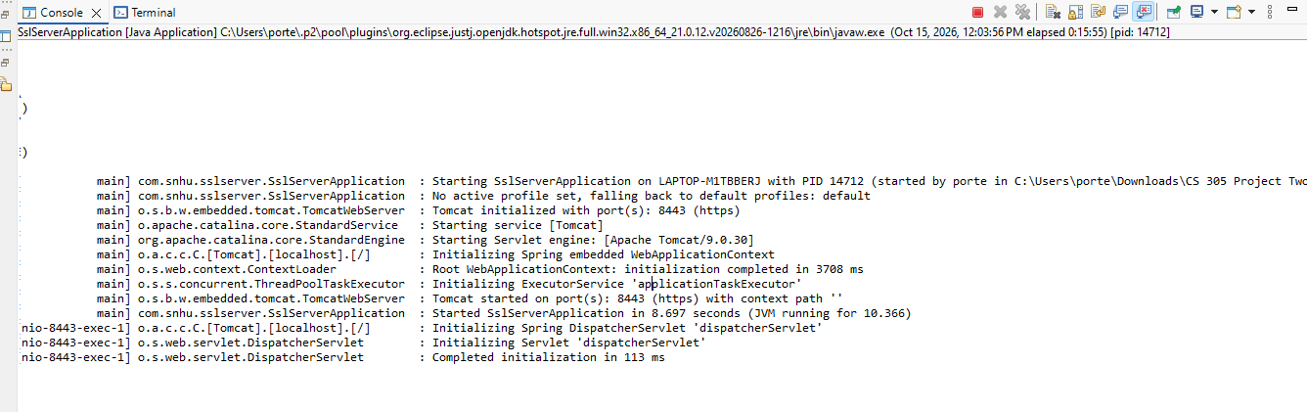

5. Secondary Testing
I integrated the OWASP Dependency-Check Maven plugin (version 13.0.0) into pom.xml and configured an NVD API key to authenticate with the National Vulnerability Database. Running mvn install executed the scan automatically.
Scan results:
- Dependency-check version: 13.0.0
- Report Generated On: Thu, 15 Oct 2026 10:56:40 -0500
- Dependencies Scanned: 49 (28 unique)
- Vulnerable Dependencies: 14
- Vulnerabilities Found: 254
- Vulnerabilities Suppressed: 0
- NVD API Last Checked: 2026-10-15T10:55:19-05
Analysis: All 254 vulnerabilities are pre-existing in the Spring Boot 2.2.4 framework and its transitive dependencies (Tomcat 9.0.30, Spring Framework 5.2.3, Jackson 2.10.2, SnakeYAML 1.25, Logback 1.2.3, and others). These dependencies were provided as part of the skeleton project and are not code I added. The SHA-256 checksum code I introduced uses only the standard Java MessageDigest class from the java.security package, which has no known vulnerabilities and introduces no new dependencies.
Screenshots of refactored code executed without errors and dependency-check report:
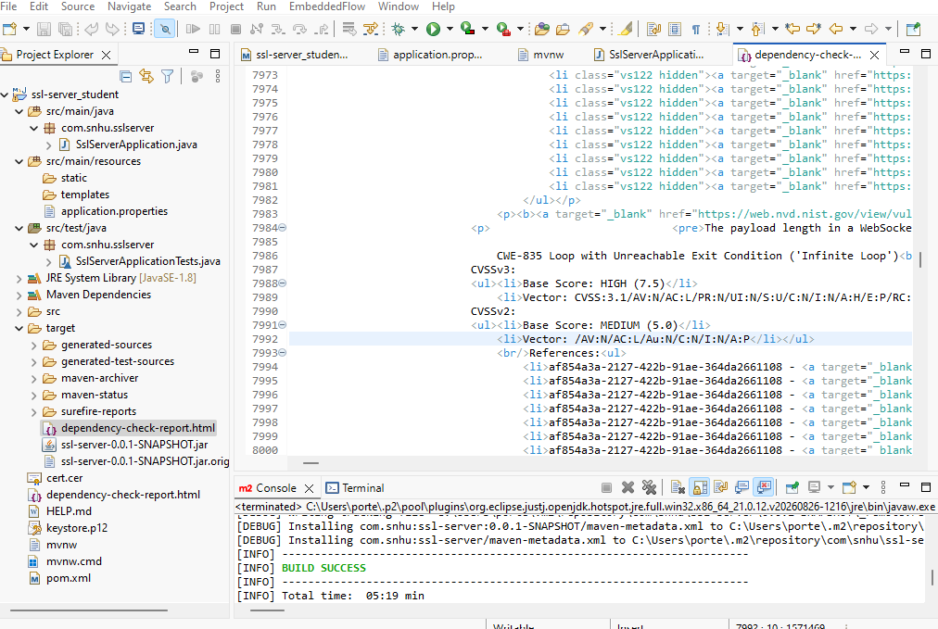
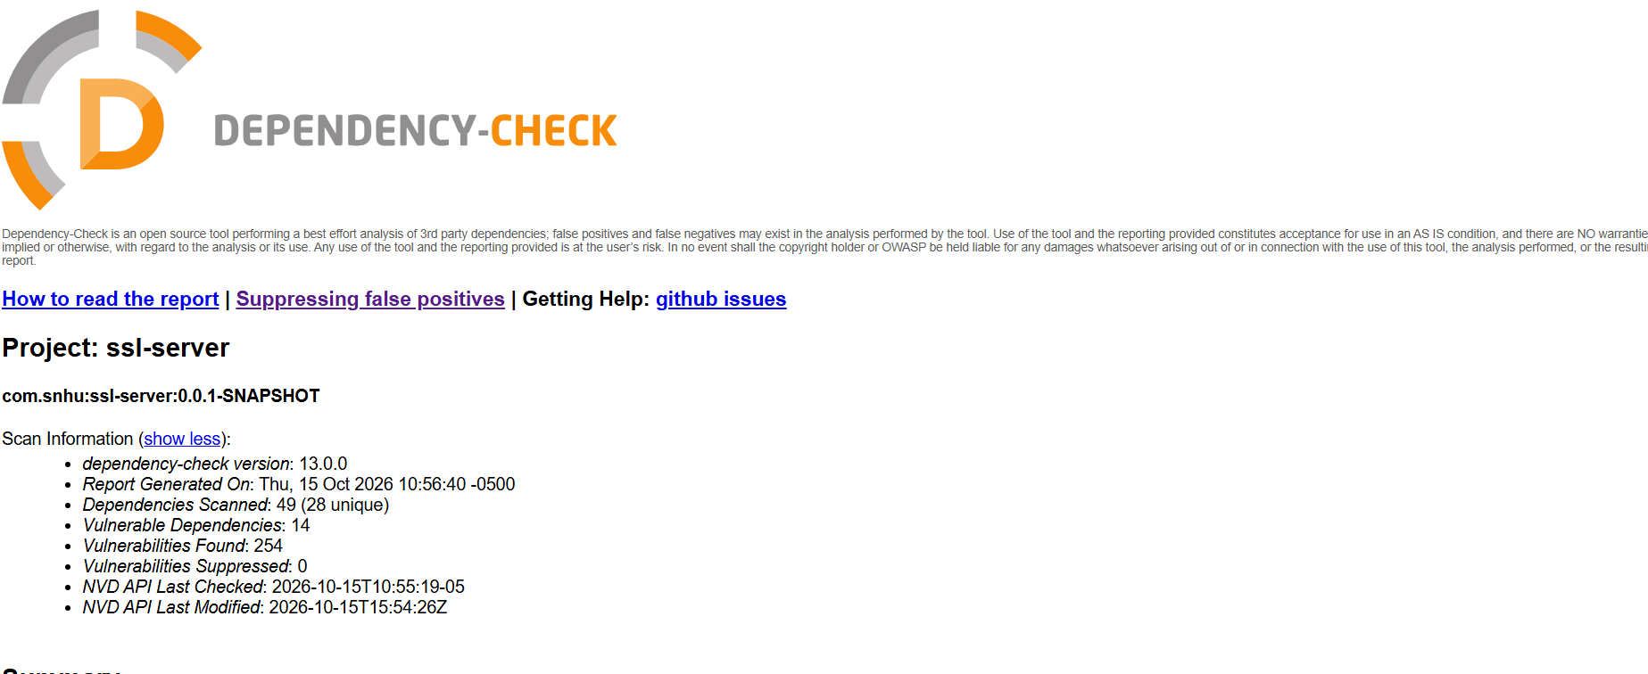

6. Functional Testing
I performed a manual review of the refactored SslServerApplication.java code to identify syntactical, logical, and security issues.
Syntactical: The code compiles without errors. The Maven build completed successfully with BUILD SUCCESS, and the Spring Boot application started in 8.697 seconds.
Logical: The /hash endpoint correctly maps to the getChecksum() method, which calls calculateSHA256 on the defined data string and returns the result as HTML. I verified the checksum by visiting the endpoint in a browser and confirming that the 64-character hex output is displayed correctly.
Security: The code uses MessageDigest.getInstance("SHA-256"), which is the current industry-standard secure hash algorithm. No hardcoded passwords, API keys, or sensitive data were introduced. The keystore password is stored in application.properties, which is appropriate for a development environment but would be externalized to environment variables in production.
Screenshot of refactored code executed without errors:

7. Summary
Referencing the Vulnerability Assessment Process Flow Diagram, I addressed the following security areas through refactoring:
- Cryptography (hash function): Added SHA-256 checksum verification for file integrity.
- Secure communication: Converted HTTP to HTTPS using a self-signed PKCS12 certificate.
- Static analysis: Integrated OWASP Dependency-Check to identify vulnerable third-party libraries.
- Input validation (via framework): Retained Spring Boot's built-in request validation.
Process for adding layers of security:
- Layer 1: Cryptographic integrity via SHA-256
- Layer 2: Transport security via TLS/HTTPS
- Layer 3: Static dependency scanning via OWASP Dependency-Check
- Layer 4: Manual code review to confirm no new vulnerabilities were introduced

8. Industry Standard Best Practices
How I maintained existing security: I did not remove or modify any existing security configurations. I kept all Spring Boot dependencies intact, preserved the existing pom.xml structure, and added the checksum endpoint as a new controller without altering existing routes.
How I applied best practices:
- Used a NIST-approved algorithm (SHA-256) rather than MD5 or SHA-1.
- Used a self-signed certificate for development while understanding that a CA-issued certificate is required for production.
- Configured the OWASP Dependency-Check plugin to fail on CVSS scores ≥ 7, which enforces a security gate.
- Followed the principle of least privilege by not exposing any new administrative endpoints.
Value to the company: Applying industry-standard secure coding practices protects Artemis Financial's client financial data, maintains customer trust, ensures regulatory compliance (GLBA, SOX, PCI-DSS), and reduces the risk of costly data breaches. Security is everyone's responsibility at Global Rain, and these practices align with that mission.

